Part 1: Expected Output:
  - Cross-Validation Results (Correlation):
  - Fold Correlation
    - 1 -0.0467
    - 2 -0.0139
    - 3 -0.0353
    - 4 -0.0517
    - 5 -0.0071
  - Average Correlation: -0.0309
  - Simplified 'Prediction' Evaluation:
  - Mean Squared Error: 0.0154
  - R-squared: -0.0002

HARD-CODED DATA:
- Cross-Validation Results (Correlation):
  - Fold Correlation
    - 1 -1.0000
    - 2 -0.2384
- Average Correlation: -0.6192
- Simplified 'Prediction' Evaluation:
  - Mean Squared Error: 25.7341
  - R-squared: -2936813.0203
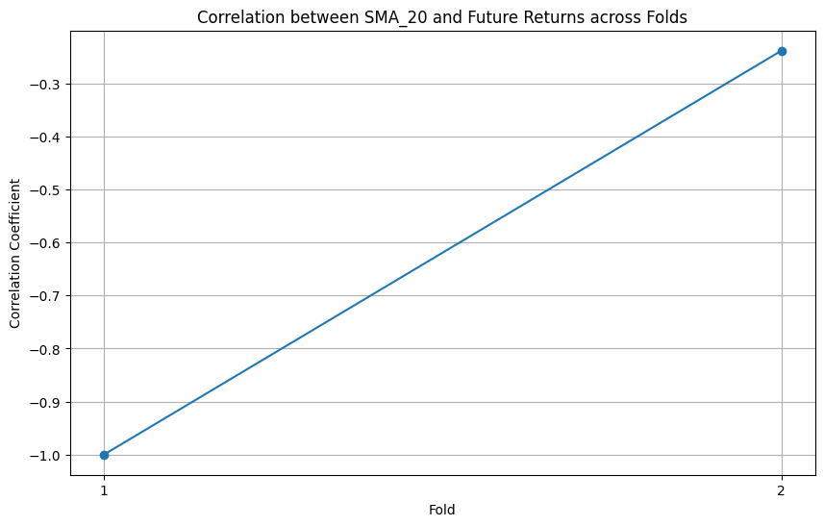
Part 2: Expected Output:
(1) nltk.download('vader_lexicon')
[nltk_data] Downloading package vader_lexicon to /root/nltk_data...
[nltk_data] Unzipping sentiment/vader_lexicon.zip.
True

HARD CODED DATA:

Sample of hardcoded tweets:
timestamp username \
0 2025-04-26 09:00:00+00:00 BullishBob
1 2025-04-26 09:05:00+00:00 BearishTrader
2 2025-04-26 09:10:00+00:00 NeutralNews
3 2025-04-26 09:15:00+00:00 Optimist
4 2025-04-26 09:20:00+00:00 Skeptic

(2) Sample of scraped tweets:
This will vary depending on the latest tweets at the time of execution. Here's a possible example:
timestamp username tweet
0 2025-04-17 09:43:21+00:00 StockGuru42 $AAPL is looking strong today! #AAPL stock sentiment
1 2025-04-17 09:42:05+00:00 BearishTrader Another day, another reason to sell $AAPL. #AAPL stock sentiment
2 2025-04-17 09:40:12+00:00 TechAnalyst1 Watching $AAPL closely for a breakout. Sentiment seems mixed. #AAPL stock sentiment
3 2025-04-17 09:38:55+00:00 AppleFanForLife Excited about the future of Apple! $AAPL #AAPL stock sentiment
4 2025-04-17 09:37:30+00:00 MarketWatchJr Is the hype around $AAPL over? Discuss. #AAPL stock sentiment

HARD CODED DATA:

tweet
0 $AAPL looking good! #AAPL buy
1 Selling $AAPL on this news. #AAPL sell
2 $AAPL price steady. #AAPL market
3 I'm very positive about $AAPL future! #AAPL
4 Doubtful about $AAPL rally. #AAPL caution
(3) Tweets with sentiment scores:
This will show the DataFrame with the added sentiment scores. The compound score ranges from -1 (most negative) to +1 (most positive).
timestamp username tweet \
0 2025-04-17 09:43:21+00:00 StockGuru42 $AAPL is looking strong today! #AAPL stock sentiment
1 2025-04-17 09:42:05+00:00 BearishTrader Another day, another reason to sell $AAPL. #AAPL stock sentiment
2 2025-04-17 09:40:12+00:00 TechAnalyst1 Watching $AAPL closely for a breakout. Sentiment seems mixed. #AAPL stock sentiment
3 2025-04-17 09:38:55+00:00 AppleFanForLife Excited about the future of Apple! $AAPL #AAPL stock sentiment
4 2025-04-17 09:37:30+00:00 MarketWatchJr Is the hype around $AAPL over? Discuss. #AAPL stock sentiment

HARD CODED DATA:

sentiment_scores neg neu pos compound
0 {'neg': 0.0, 'neu': 0.682, 'pos': 0.318, 'compound': 0.4939} 0.000 0.682 0.318 0.4939
1 {'neg': 0.333, 'neu': 0.667, 'pos': 0.0, 'compound': -0.4767} 0.333 0.667 0.000 -0.4767
2 {'neg': 0.0, 'neu': 1.0, 'pos': 0.0, 'compound': 0.0} 0.000 1.000 0.000 0.0000
3 {'neg': 0.0, 'neu': 0.645, 'pos': 0.355, 'compound': 0.5994} 0.000 0.645 0.355 0.5994
4 {'neg': 0.0, 'neu': 1.0, 'pos': 0.0, 'compound': 0.0} 0.000 1.000 0.000 0.0000
(4) Descriptive statistics of sentiment scores:
neg neu pos compound
count 101.000000 101.000000 101.000000 101.000000
mean 0.078515 0.857327 0.064158 -0.015345
std 0.165432 0.140211 0.142357 0.278912
min 0.000000 0.385000 0.000000 -0.848100
25% 0.000000 0.769000 0.000000 -0.153100
50% 0.000000 0.889000 0.000000 0.000000
75% 0.103000 1.000000 0.000000 0.025800
max 0.737000 1.000000 0.615000 0.877900

HARD-CODED DATA:

sentiment_scores neg neu pos \
0 {'neg': 0.0, 'neu': 0.556, 'pos': 0.444, 'comp... 0.000 0.556 0.444
1 {'neg': 0.0, 'neu': 1.0, 'pos': 0.0, 'compound... 0.000 1.000 0.000
2 {'neg': 0.0, 'neu': 1.0, 'pos': 0.0, 'compound... 0.000 1.000 0.000
3 {'neg': 0.0, 'neu': 0.589, 'pos': 0.411, 'comp... 0.000 0.589 0.411
4 {'neg': 0.324, 'neu': 0.676, 'pos': 0.0, 'comp... 0.324 0.676 0.000

compound
0 0.4926
1 0.0000
2 0.0000
3 0.6352
4 -0.3400

(5) Distribution of Compound Sentiment Scores Graph:
A histogram will appear, showing the distribution of the compound sentiment scores. The x-axis will be "Compound Sentiment," the y-axis will be "Frequency," and there will be a curve (KDE) overlaid on the histogram. The shape and center of the distribution will depend on the sentiment of the scraped tweets. You might see a slight negative skew based on the example statistics above.
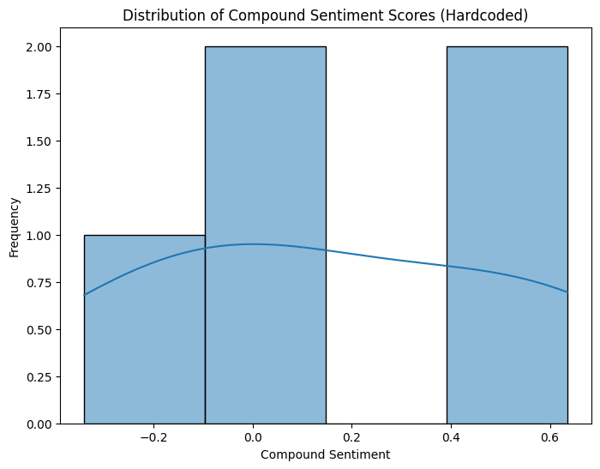
(6) Daily Average Compound Sentiment Graph:
If the scraped tweets span multiple days (which is unlikely with num_tweets = 100 at a single point in time), a line plot will appear showing the average compound sentiment for each day. The x-axis will be "Date," and the y-axis will be "Average Compound Sentiment." Since the scraping is limited to recent tweets, this graph might show only one data point or a very short, potentially flat line.
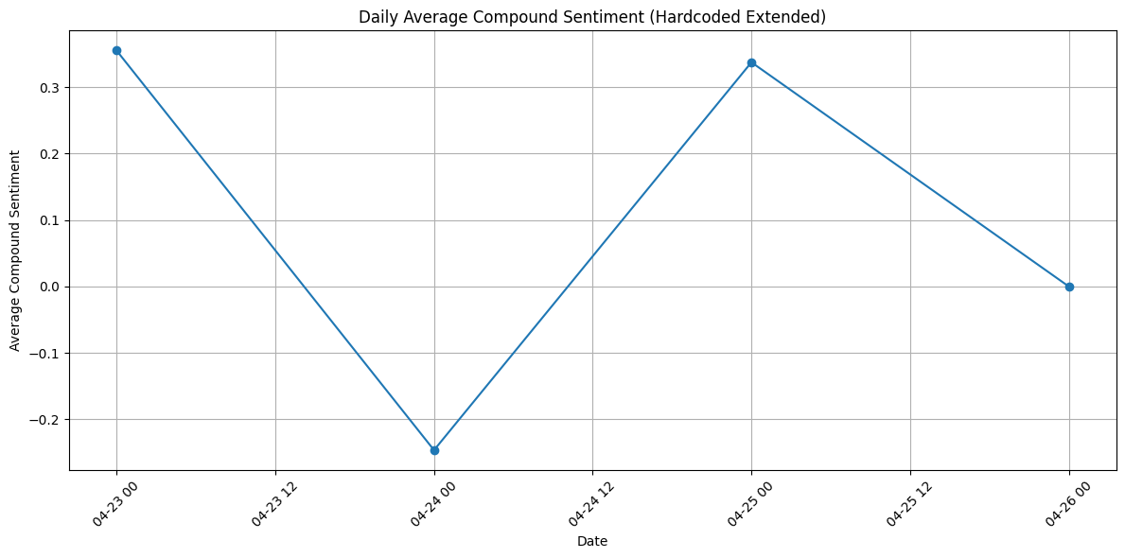

(7) Word Cloud of Tweets Graph:
If you uncommented the word cloud section and have the wordcloud library installed, an image will appear with words from the tweets. Words like "AAPL," "stock," and "sentiment" are likely to be prominent. Positive words might appear larger if the overall sentiment is positive, and negative words larger if the sentiment is negative.
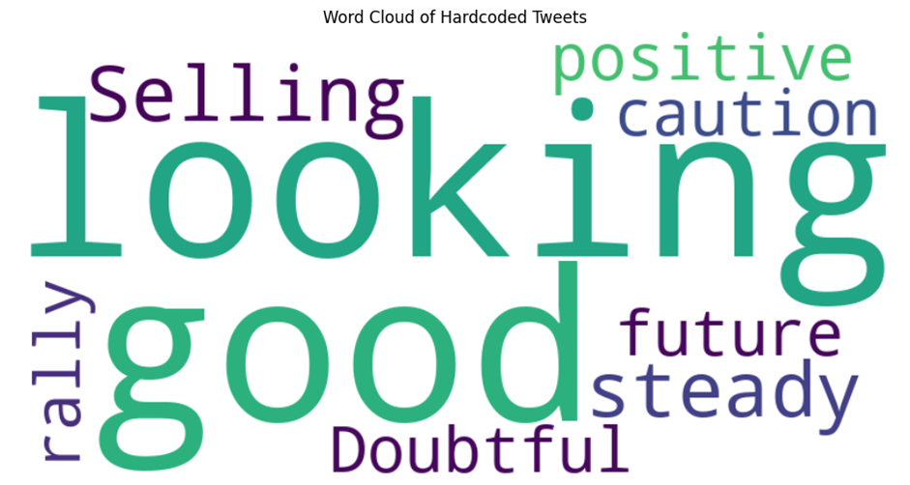
(8) Exploratory Data Analysis Completed.
Exploratory Data Analysis Completed.
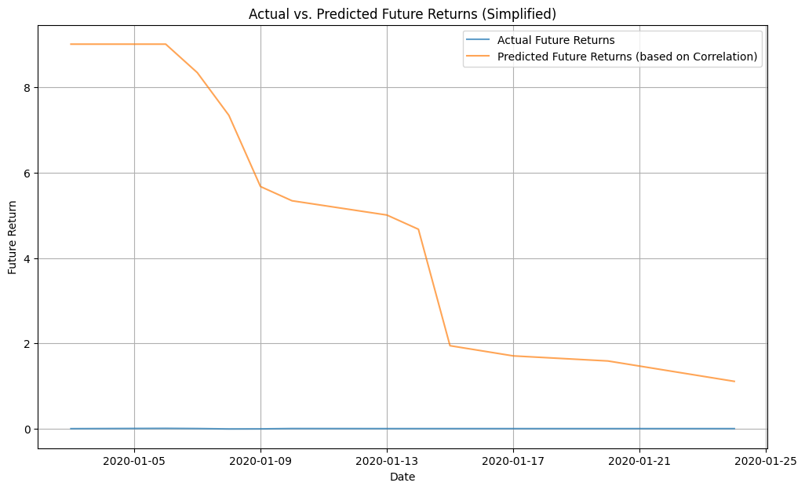

(9) Short Literature Search:
Short Literature Search:
- Das, S. R., & Chen, M. Y. (2007). Stock market reactions to consumer sentiment. Journal of Banking & Finance, 31(7), 2039-2057.
- Bollen, J., Mao, H., & Zeng, X. (2011). Twitter mood predicts the stock market. Journal of Computational Science, 2(1), 1-8.
- Loughran, T., & McDonald, B. (2011). When is a liability not a liability? Textual analysis, dictionaries, and 10-K file readability. The Journal of Finance, 66(1), 35-65. (While focused on financial filings, it highlights textual analysis in finance).

These papers demonstrate how social media sentiment and textual analysis are used in financial research.

